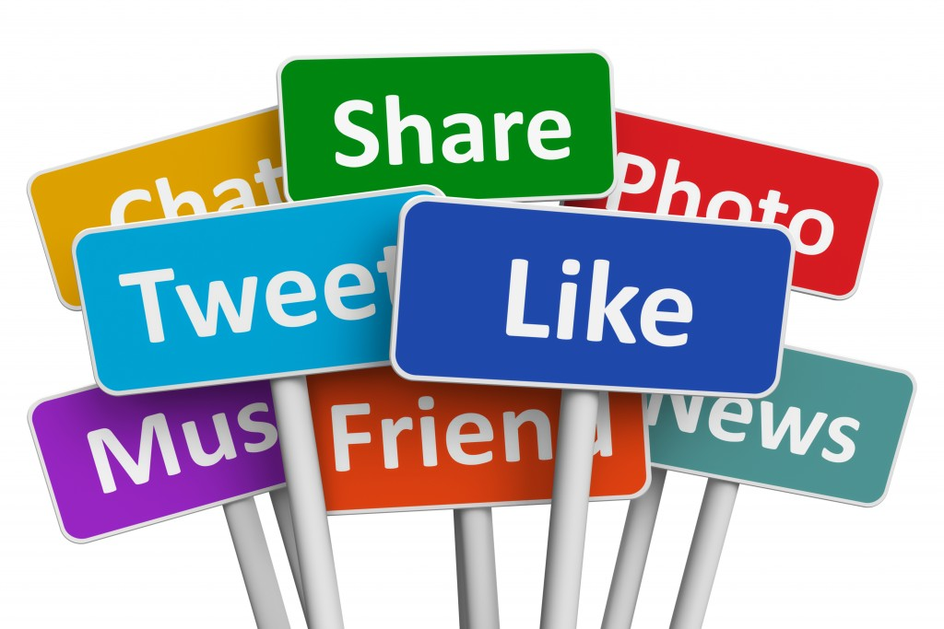
Social Media Analysis

BY Neelam Rajput
DS November 2025
Objective questions
Q-1.Are there any tables with duplicate or missing null values? If so, how would you handle them?
Answer-
Approach:
I generated a query using a group by clause over the presented columns in tables and used count function on the basis of all columns. Columns having count greater than 1 will appear else there will be no duplicates in data .
To check null values I used where clause to get the record having null values in result.
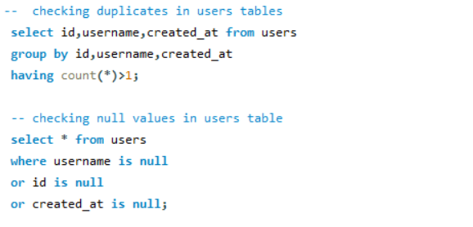
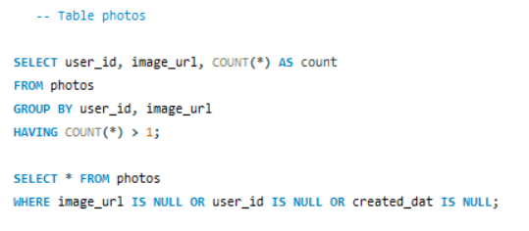
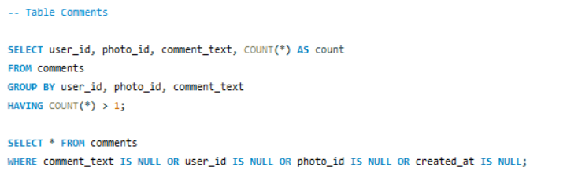
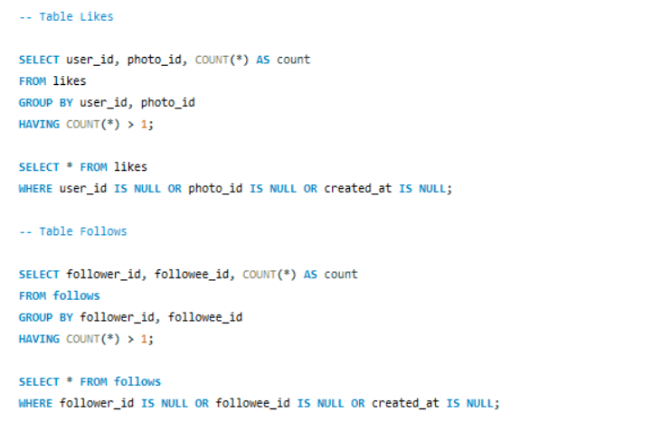 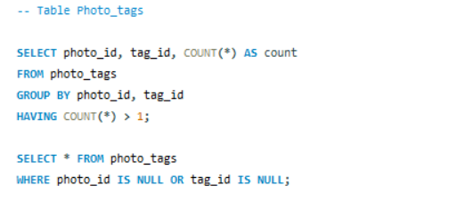
Insights :
While checking for all tables no record was available for nulls and duplicates. Hence ,no duplicates and null are there.

Q-2.What is the distribution of user activity levels (e.g., number of posts, likes, comments) across the user base?
Answer -To analyze the user activity I calculated the total likes,number of post
and number of comments done.
- Used left join to connect all activity tables(i.e.likes,comments,photos)
to users table to include all users even when they have no record in all activity tables.
- Used the count function to calculate the number of likes,comments and posts and grouping the data on basis of username using group by.
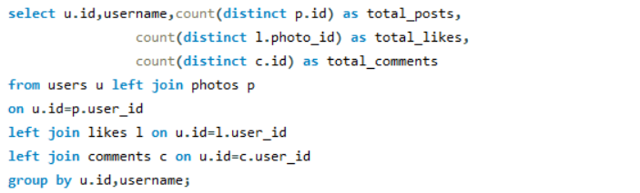
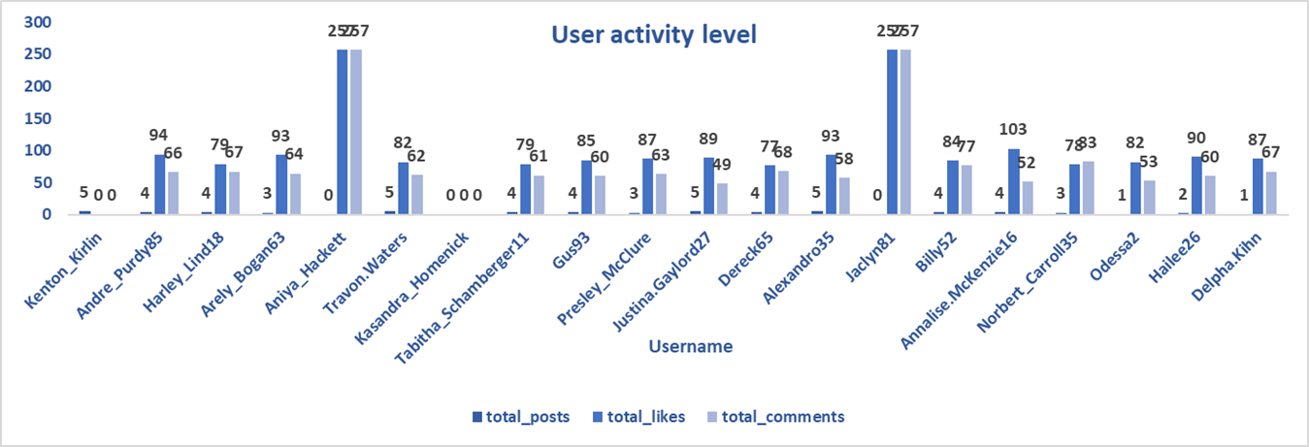
Q-3.Calculate the average number of tags per post (photo_tags and photos tables).
Answer-
Approach:-To calculate the average number of tags per post I first calculated the Number of tags per post by joining photos and photo_tags table using left join and then using the result as subquery to calculate average .
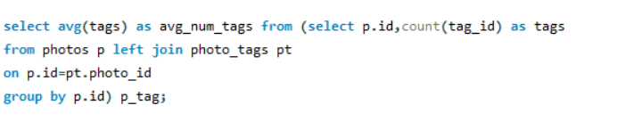
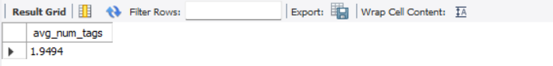
Q-4.Identify the top users with the highest engagement rates (likes, comments) on their posts and rank them.
Answer –
Approach:> Used left join and subquery to calculate engagement rate.
>I calculated total likes and total comments an user got over their post and divided their sum by total post to get total engagement and ranked their engagement value using dense_rank function assigning the highest values the top ranks .
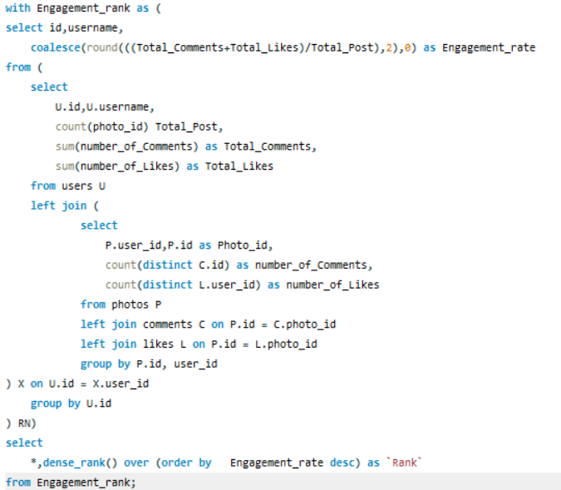
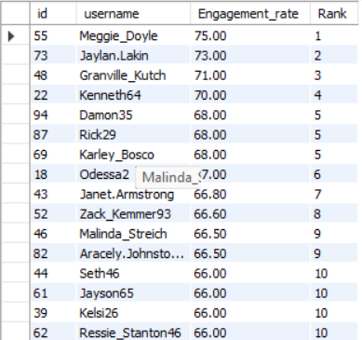

Q-5.Which user has the highest number of followers and followings?
Answer-
Approach:-To find the user having the highest number of followers and followings
- I made two CTEs cte1 to find the number of followers and cte2 to find the number of followees using the count function along with group by clause.
- Then joined both CTEs with users table using left join to find the number of followers and number of followings for all 100 users .
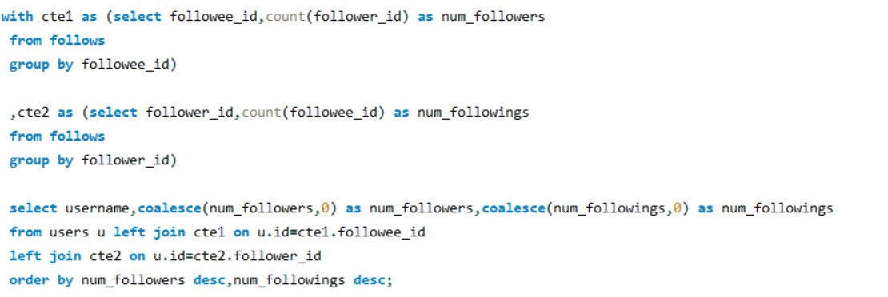
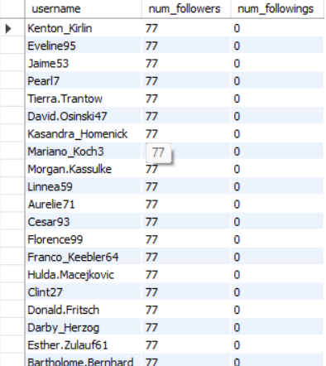

Q-6.Calculate the average engagement rate (likes, comments) per post for each user.
Answer-
Approach:-
>To calculate average engagement rate I calculated number of posts done by user,likes they got and comments done over their posts in subquery part and used them in case when statement to calculate sum of number of likes and number of comments and divide them by number of posts done by them where number of posts are not zero and zero for those who didn’t post anything .
>used Left Join to join tables so that all the users all Include.
>COALESCE() function is used to handle NULL values and replace null with.
>Average Engagement rate is sum of total likes and total comments divided by
total posts done by the user.
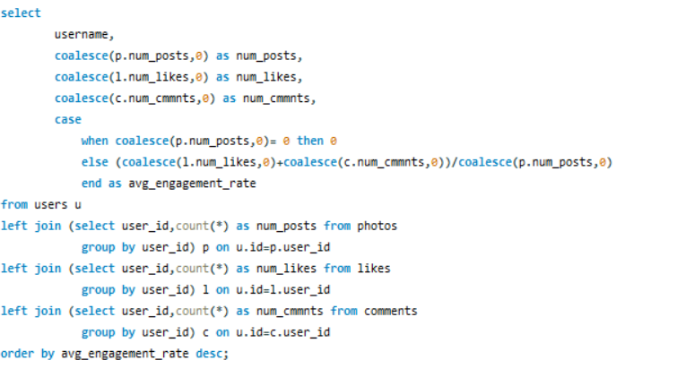
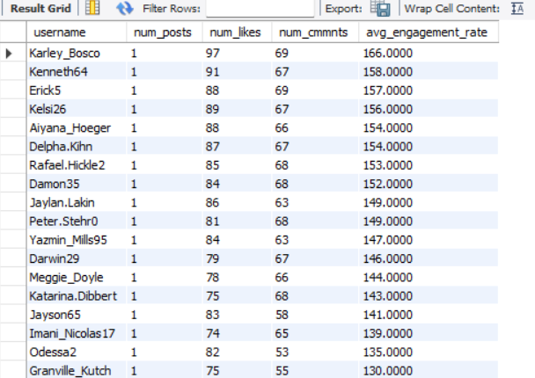
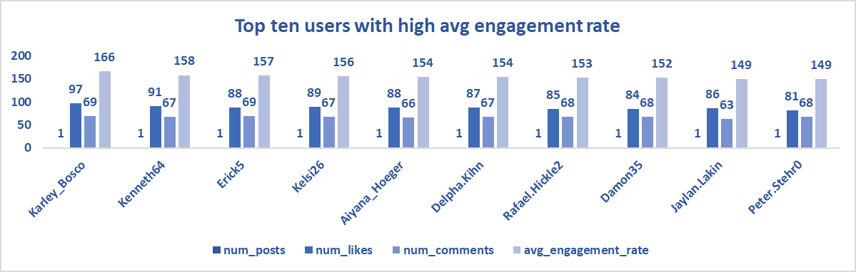
Q-7.Get the list of users who have never liked any post (users and likes tables)
Answer-
Approach:-To get the users who never liked any post i find the user who liked the posts and
used that part in not in condition to filter out the users who never liked any posts.
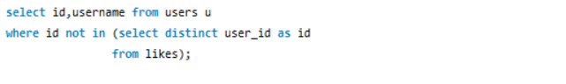
Insights :-Got a list of 21 users who never liked a post .
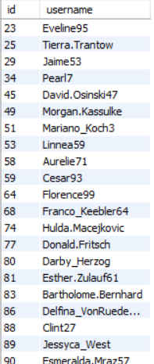
Q-8.How can you leverage user-generated content (posts, hashtags, photo tags) to create more personalized and engaging ad campaigns?
Answer-
Approach-I used hashtags and photo tags to identify trending topics and popular content categories. Based on this analysis, I grouped users with similar interests and targeted them with ads that matched their behaviour and engagement patterns. By using real user-generated content, the ads felt more authentic and relevant, which helped improve user engagement, click-through rates, and overall campaign effectiveness
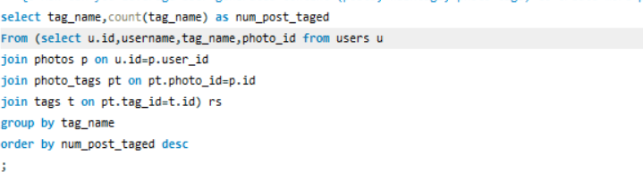
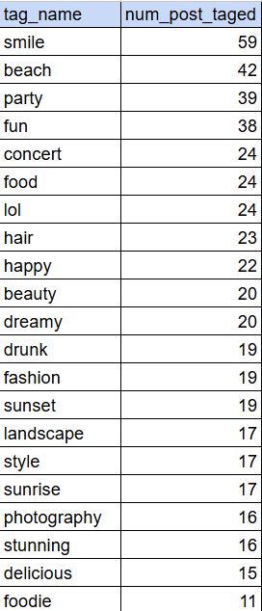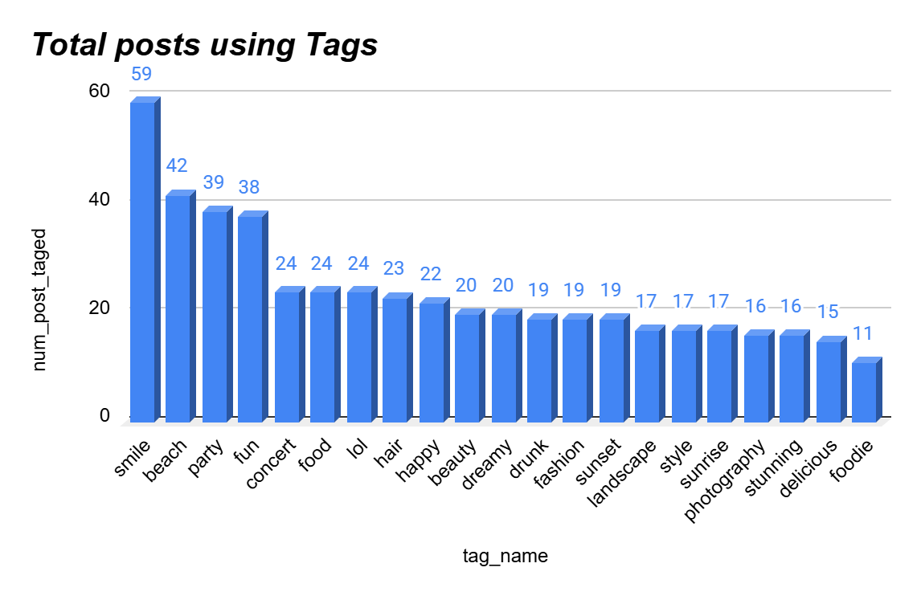
Q-9.Are there any correlations between user activity levels and specific content types (e.g., photos, videos, reels)? How can this information guide content creation and curation strategies?
Answer-
Approach-
>To find the correlation first I calculated the activity engagement on the basis of tags used and number of post done with that tag, likes it got and comments done on that tagged post .
>Summarize total engagement of users on the basis of tag by calculating the activity sum and Ordered avg engagement in descending to prioritize high-performing content types based on total user interaction.
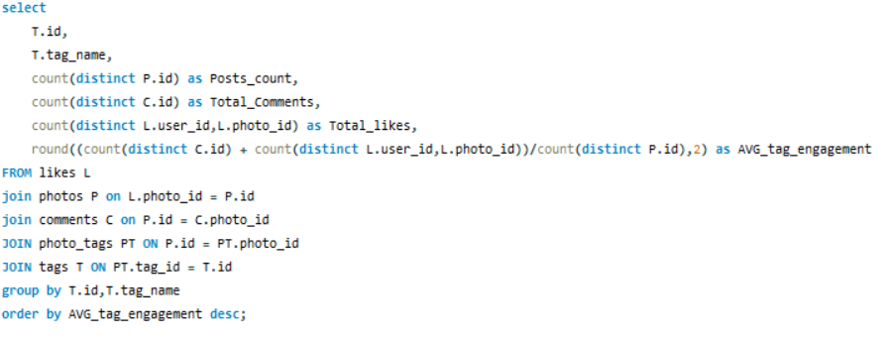
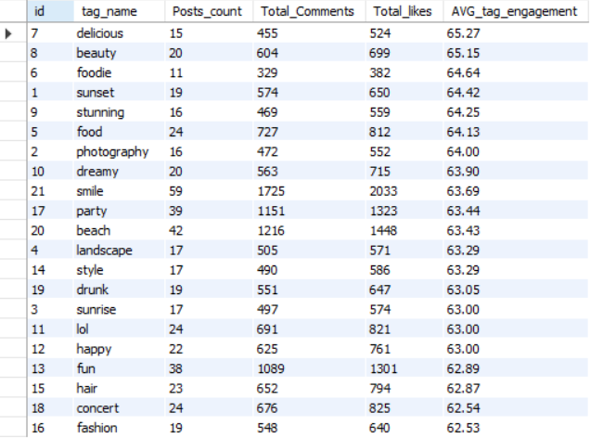
These insights can guide the content creation and curation strategies by prioritizing high-performing formats and optimizing future content to maximize user interaction.
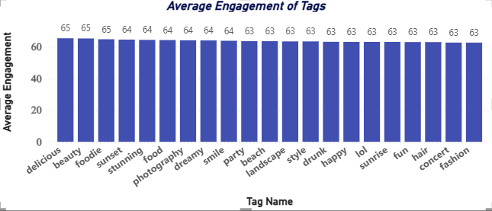
10.Calculate the total number of likes, comments, and photo tags for each user.
Answer:
Approach-
->To calculate the number of likes,comments and photo tags for each user first I calculated the count of likes ,comments and photo tag for each user in subquery and joined the results with main user tables using left join .
->used coalesce function to handle null values and assign them 0 if its null.
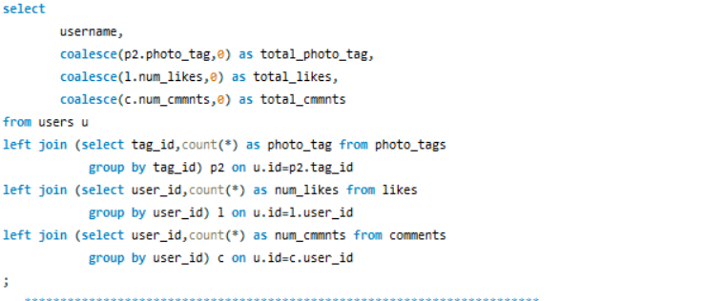
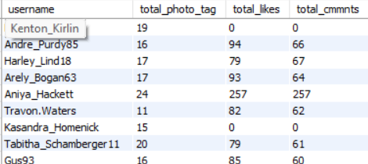
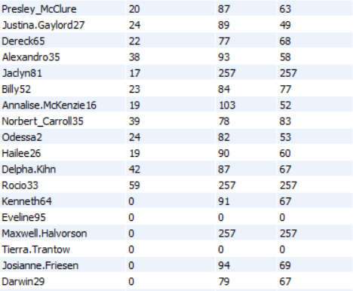

Q-11. Rank users based on their total engagement (likes, comments, shares) over a month.
Answer:
Approach-
>To calculate the monthly engagement for given dataset for july 2024 I created a cte
having total likes,total comments and sum of likes and comments as engagement from
table users and joining it with the aggregated subquery needed for calculation.Used where clause to filter out the date for july month only.
->used count() function with group by clause to calculate total likes and comments per user.
By using julyengagement CTE ranked the data using the RANK() window function in descending order of total engagement to identify the most engaged users for the month.
->Used Coalesce() function to handle null values and assign 0 if null.
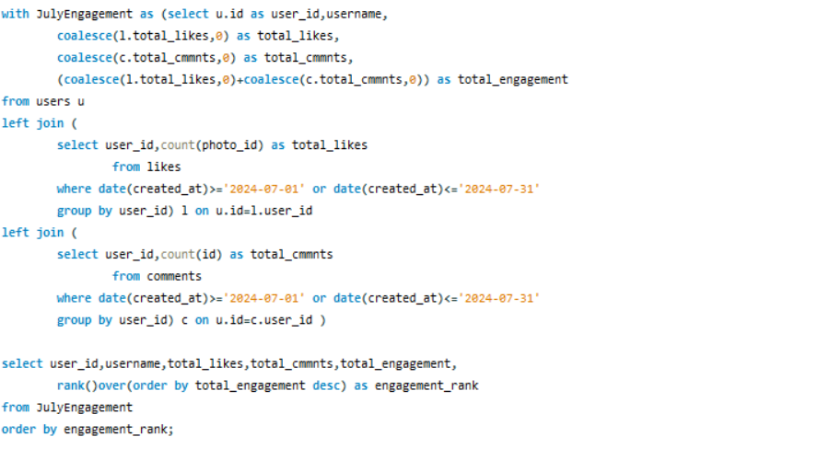
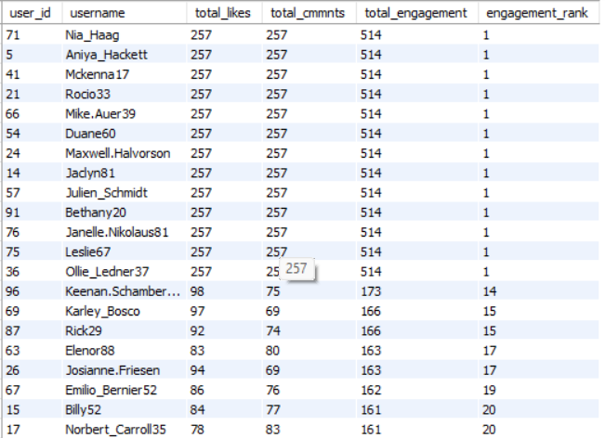
Q-12.Retrieve the hashtags that have been used in posts with the highest average number of likes. Use a CTE to calculate the average likes for each hashtag first.
Answer-
Approach-
To identify the hashtag I first created a Common Table Expression named avg_likes_per_hashtag to calculate the average likes for each hashtag. In the CTE, I joined the tags, photo_tags, and photos tables to associate hashtags with their respective posts. I then used a LEFT JOIN with the likes table to count the number of likes received by each photo. I calculated the average likes per hashtag by dividing the total number of likes by the distinct number of posts associated with that hashtag. After computing the average likes, I selected the hashtags from the CTE and ordered them in descending order of average likes. Finally, I limited the result to the top five hashtags with the highest average engagement.
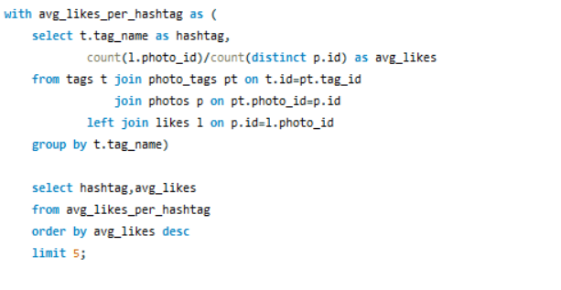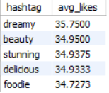
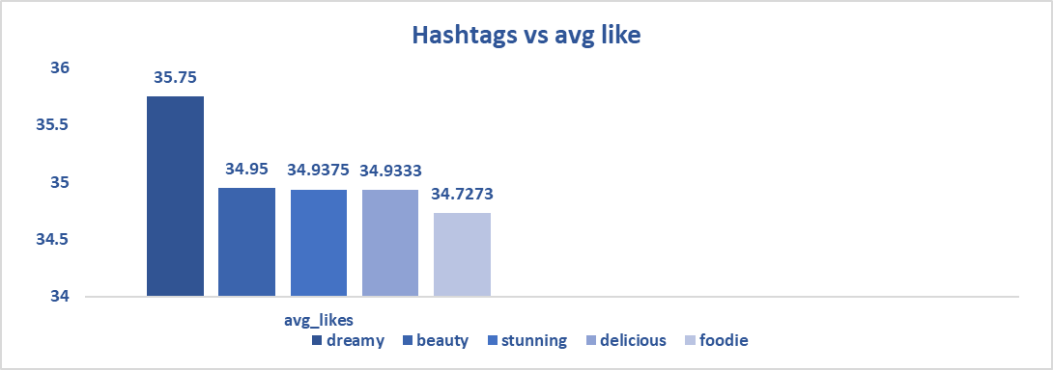
Q-13.Retrieve the users who have started following someone after being followed by that person.
Answer-
Approach:
I performed an analysis on the allotted dataset to identify users who started following someone after being followed by that same person. To achieve this, I used a self-join on the follows table. Joined the follows table with itself by matching cases where one user follows another and the other user follows back. I then compared the created_at timestamps to determine the follow-back sequence.
By filtering records where the follow-back time occurred after the initial follow, I identified users who followed someone only after being followed first. This helped detect reciprocal follow behavior based on time order.
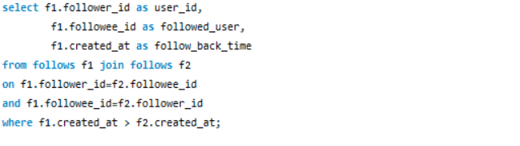
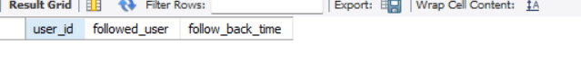
Insights- No user found who started following the user back after getting followed by that user.
Subjective Questions
Q-1.Based on user engagement and activity levels, which users would you consider the most loyal or valuable? How would you reward or incentivize these users?
Answer-
Approach- Created multiple CTEs to calculate total likes, total comments,total followers,total posts and total tags for each user .
> Join each CTE with users tables using left join and sum total likes and total comments to calculate total engagement.
> order the result in descending order on basis of engagement to get the top users.
>Use COALESCE() function to handle NULL values .
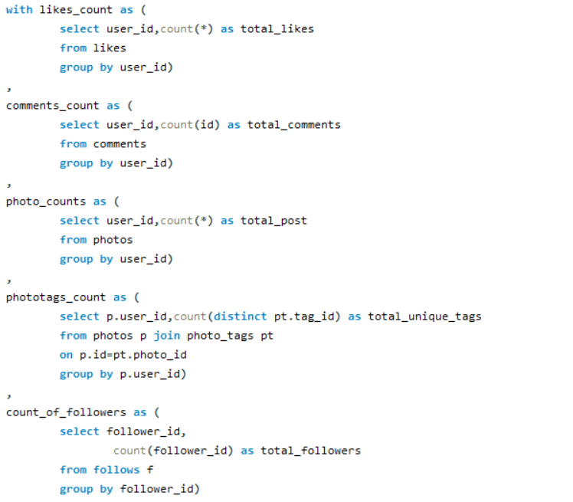
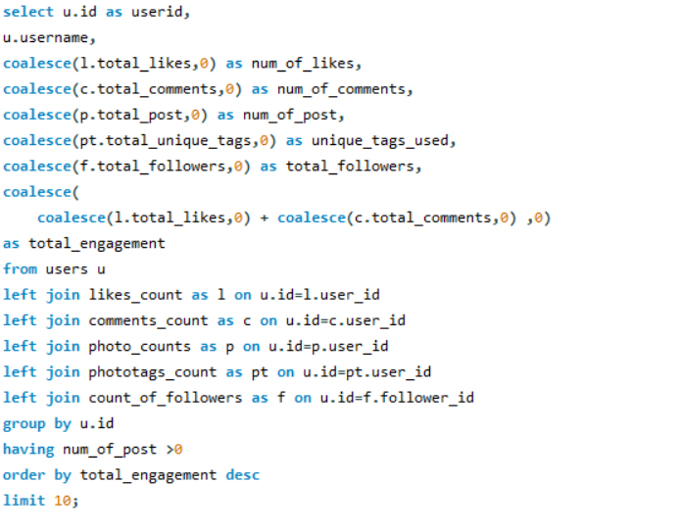
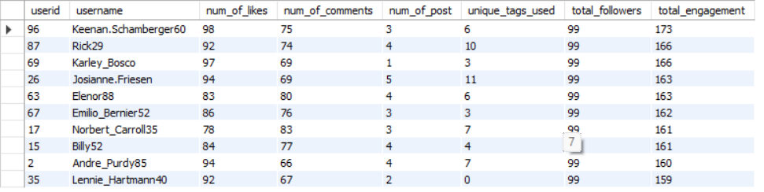Insights-
Keenan.Schamberger60 : With a total engagement of 173, they are the most active, even though they only have 3 posts. They likely have a very "sticky" following that responds to everything they do.
Engagement: Notice Karley_Bosco. They only have 1 post, but a massive 166 engagement. This user is a "Viral Wonder"—they don't post often, but when they do, the community reacts intensely.
Tag Versatility: Josianne.Friesen is your most versatile user (11 unique tags).
This suggests they are active in many different sub-communities on your
platform, making them valuable for cross-promoting different types of
content.
Q-2.For inactive users, what strategies would you recommend to re-engage them and encourage them to start posting or engaging again?
Answer-
Approach:> Created a CTE having the number of posts done by an user from users and photos table by joining them using LEFT JOIN.
> Using the CASE-END statement to flag the users as “Active User” or “Inactive User”.
>filter the user flagged as “Inactive User” .
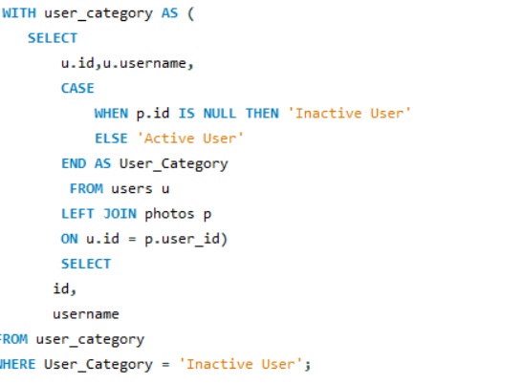
Insights:
> Out of total 100 Users only 74 Users are Active and posted something.
>There are 26 Users in dataset who are inactive and didn’t posted anything.
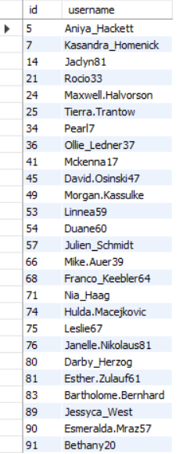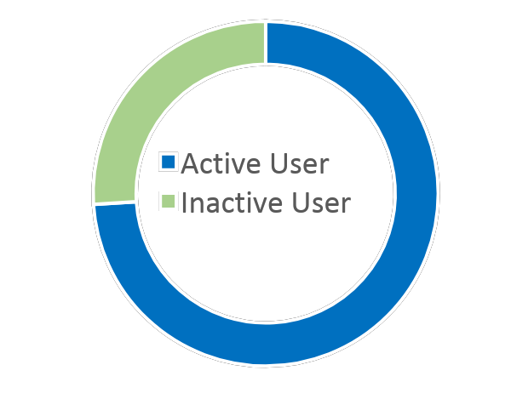
>Recommend strategies to re-engage them and encourage them
- Personalized Outreach Campaigns: Send personalized messages or emails highlighting new features, updates, or content they may have missed, based on their past activity, making them feel valued and invited back.
- Exclusive Incentives and Rewards: Offer limited-time promotions like special badges, profile boosts, or access to premium features to encourage them to post or engage with content again.
- Gamification and Challenges: Introduce interactive challenges, user milestones, or leaderboard systems to motivate users through friendly competition or achievements, making the platform more engaging and fun.
- Content Recommendations and Reminders: Use algorithms to recommend content they might like based on past interactions, along with gentle reminders about new posts or trending topics that fit their interests.
- Community Engagement and Social Features: Encourage them to join community groups or follow trending topics, where they can participate in discussions, comment on posts, or collaborate with others, fostering a sense of belonging and active involvement.
Q-3. Which hashtags or content topics have the highest engagement rates?How can this information guide content strategy and ad campaigns?
Approach:
> Created two CTEs named tag_engagement and Engagement_rate .
>CTE tag_Engagement contains details like total likes ,total comments and total photos posted with a tag .
>CTE Engagement_rate has details of total likes ,comments and engagement rate of a tag name from tag_engagement CTE.
>values are calculated in CTEs using Count and Group by clause.
>Total Engagement is ordered in descending order to get highly engaging tags.
>Left join is used to Join tables to make sure each tag name is included either the post has like-comment or not.
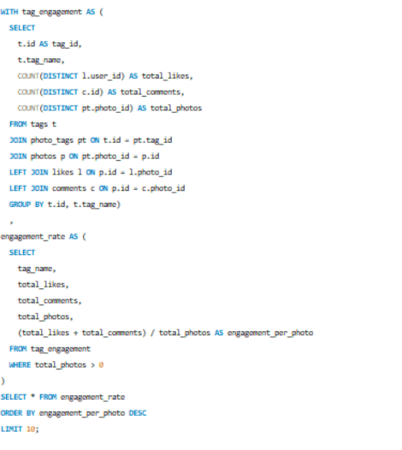
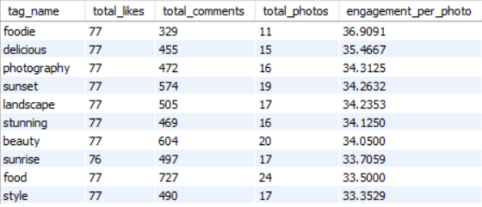
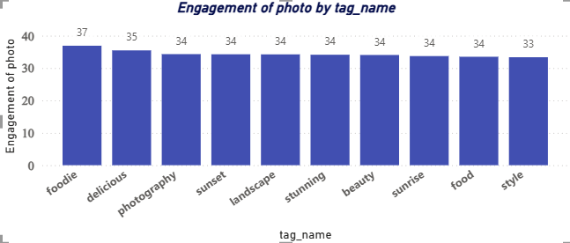
Insights:
> The "smile" tag is your top performer by a significant margin, with 59 total photos and 59 engagement.
> Following "smile" the next highest-performing tags are "beach" (42), "party" (39), and "fun" (38). This reveals that the platform is primarily used for sharing high-energy, aspirational, or recreational experiences.
1. Guiding Your Content Strategy
The data shows that your audience responds best to emotional and high-energy content.
- Double Down on "Human" Content: Since "smile" is your top-performing tag, your primary content pillar should be people-centric. Shift away from product-only shots and move toward photos showing faces, emotions, and genuine reactions.
- Leverage "Lifestyle" Anchors: The high engagement for "beach" and "party" suggests your audience uses the platform for inspiration and escapism. Use these themes to frame your message, even if your product is functional.
- Fill the "Middle Tier" Gaps: Tags like "food" and "concert" are reliable. Use these for "filler" content between major posts to maintain a consistent baseline of engagement without burning out your audience.
2. Optimizing Ad Campaigns
- Creative Selection: Use the Top 3 Tags (Smile, Beach, Party) as the creative foundation for your ads. An ad featuring a smiling person at a social event is statistically more likely to convert based on your current engagement levels.
- .A/B Testing Framework: Use your 1 engagement rate as a benchmark. Run two ads—one using a high-volume tag (Smile) and one using a niche tag (Beauty). If the "Smile" ad doesn't exceed the 1.0 rate, you may need to refine your audience targeting.
- Retargeting Strategy: Users who engage with "lifestyle" tags (Beach/Party) can be retargeted with specific product offers. Since they’ve already shown interest in these categories, the "friction" to buy is much lower.
Q-4. Are there any patterns or trends in user engagement based on demographics (age, location, gender) or posting times? How can these insights inform targeted marketing campaigns?
Answer-
Approach:
>Used Hour() function to calculate hour from the date and dayname() function to calculate the dayname of date.
>count() function is used to calculate the number of post,likes and comment.
>group by clause is used group the result on basis of posting hour and posting day.
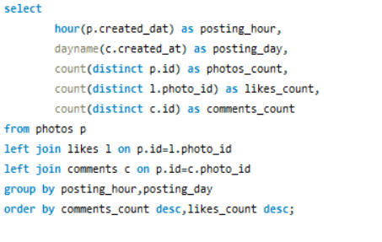
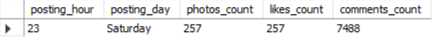Recommendations:
>From a marketing strategy perspective, these insights can be used to optimize campaign timing. By scheduling content and advertisements during high-engagement periods, marketers can maximize visibility, improve click-through rates, and increase overall campaign effectiveness.
>Time-based targeting ensures that ads reach users when they are most active and receptive.
Q-5.Based on follower counts and engagement rates, which users would be ideal candidates for influencer marketing campaigns? How would you approach and collaborate with these influencers?
Answer-
Approach-
> Different CTEs are created to calculate total likes for an user ,total comments and total followers the user has.
> Used COALESCE() function to handle null values .
> To calculate Engagement Rate sum of total likes and total comments is divided by total post done by user .Hence, result value shows the engagement per post.
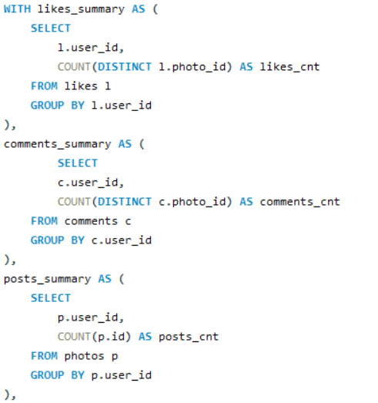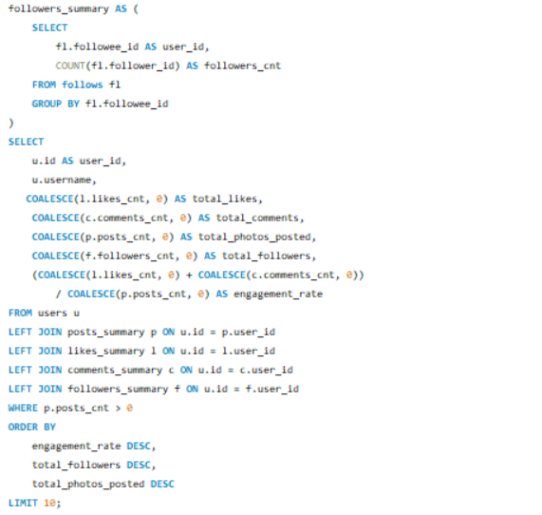

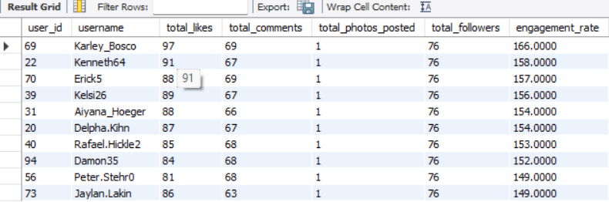
Insights :
>Based on engagement efficiency and follower reach, users with the highest engagement rates per post represent the most valuable influencer candidates.
> This data proves that you don't need a high total_photos_posted count to be influential. A single, well-tagged post (like a "Smile" or "Beach" photo) can drive more brand awareness than 10 mediocre posts.
To Approach and Collaborate
- The "Early Access" Hook: Reach out to Karley_Bosco or Kenneth64 and offer them early access to new platform features or "Beta" tags. Because they have high engagement, they are the best people to test if a new feature will be popular.
- Product Seeding: Instead of paying them a flat fee (which might feel awkward for someone with 76 followers), send them a "Thank You" gift. For example, since you’re already looking at desk upgrades, a high-quality lamp could be a great "Welcome to the Creator Program" gift.
- The "Feature" Strategy: Ask to "Pin" or "Feature" their one high-performing post on the main discovery page. In exchange, ask them to post a second photo using a specific brand tag. This tests if they can replicate their viral success.
Q-6. Based on user behavior and engagement data, how would you segment the user base for targeted marketing campaigns or personalized recommendations?
Answer-
Approach:-
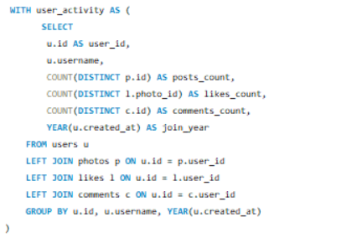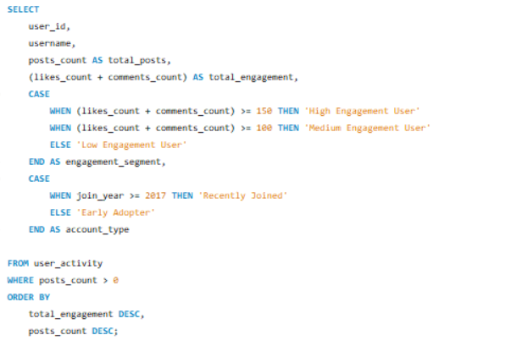
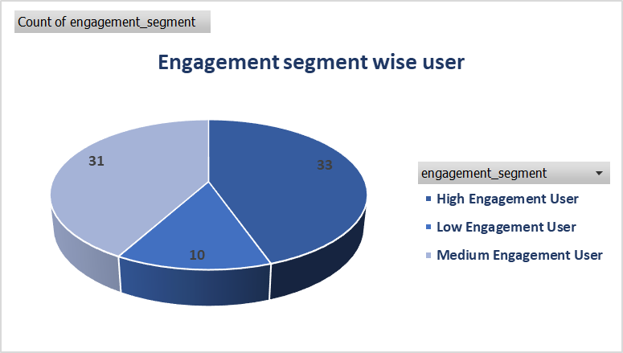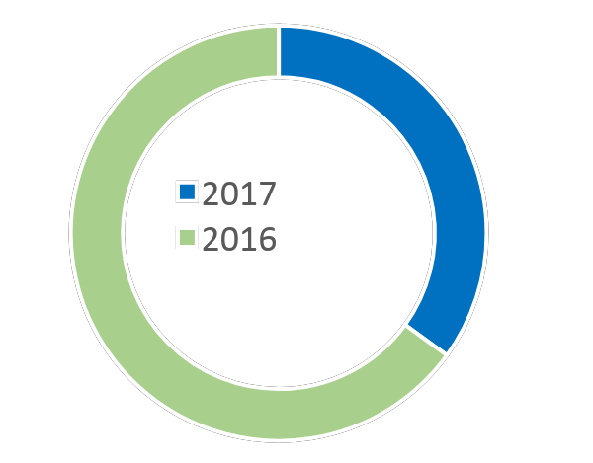
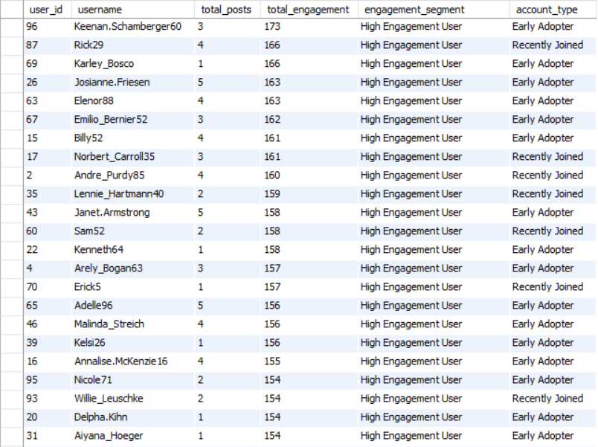
Insights:-
- Users with total engagement greater than or equal to 150 were classified as High Engagement Users
- Users with total engagement between 100 and 149 were classified as Medium Engagement Users
- Users with total engagement less than 100 were classified as Low Engagement Users.
- 35 Users who joined in or after 2017 were categorized as Recently Joined, while 65 users who joined before 2017 were categorized as Early Adopters.
Q-7.If data on ad campaigns (impressions, clicks, conversions) is available, how would you measure their effectiveness and optimize future campaigns?
Answer-
To evaluate the effectiveness of advertising campaigns, businesses must go beyond surface-level metrics and focus on indicators that reflect both performance and business impact.The goal is not only to measure how widely an ad is seen, but how effectively it drives user action and contributes to business outcomes.
Measuring Campaign Effectiveness
- Ad performance is assessed using a combination of reach, engagement, and conversion metrics:
- Impressions measure campaign visibility and brand exposure, helping assess whether the target audience is being reached at scale
- Clicks and Click-Through Rate (CTR) indicate how compelling the ad creative and messaging are. A strong CTR reflects effective targeting and relevance.
- Conversion Rate evaluates how efficiently user interest translates into desired actions, such as purchases or sign-ups, and highlights the effectiveness of the landing page and overall user journey.
- Engagement Metrics (such as interactions or time spent) provide insights into brand resonance and long-term value, even when immediate conversions are low.Together, these metrics provide a holistic view of campaign performance across the marketing funnel.
- Optimizing Future Campaigns Insights derived from performance data are used to continuously improve campaign effectiveness:
- Creative Optimization: High-performing ad creatives are scaled, while underperforming variations are refined or replaced through A/B testing.
- Audience Optimization: Budget is redirected toward audience segments with higher conversion potential, ensuring more efficient use of marketing spend.
- Channel and Placement Optimization: Investment is shifted toward platforms, placements, and time windows that deliver stronger engagement and conversions.
- Retargeting Strategies: Users who show interest but do not convert are re-engaged with personalized messaging to improve conversion outcomes.
Continuous Performance Monitoring: Campaigns are regularly reviewed, enabling agile adjustments to strategy, creatives, and budgets in response to real-time data.

Q-8.How can you use user activity data to identify potential brand ambassadors or advocates who could help promote Instagram's in
itiatives or events?
Answer-
- Identifying Potential Brand Ambassadors Using User Activity Data
User activity data can be strategically leveraged to identify highly influential and engaged users who can act as brand ambassadors or advocates for Instagram’s initiatives and events.The objective is to select users who not only have reach but also demonstrate strong platform loyalty and positive engagement behaviour.
- Key Data Signals to Identify Brand Ambassadors
- Engagement Level: Users with consistently high engagement rates (likes, comments, shares, saves) indicate strong content resonance and audience interaction.
- Content Consistency: Users who post regularly and maintain sustained engagement over time show reliability and long-term platform commitment.
- Audience Interaction Quality: Users whose content generates meaningful conversations (comments, replies, story interactions) are more likely to influence community behavior.
- Network Influence: Users whose posts lead to secondary engagement (reshares, mentions, follower growth) demonstrate influence beyond their immediate audience.
- Platform Advocacy Behavior: Users who organically promote Instagram features (Reels, Stories, Live, Events) without incentives signal authentic brand alignment.
- Analytical Approach
- Segment users based on engagement intensity, posting frequency, and interaction quality.
- Identify top-performing users within each segment using percentile ranking or engagement thresholds.
- Analyze historical data to ensure consistent performance rather than one-time viral activity.
- Cross-reference engagement data with follower growth trends to assess influence scalability.
- Business Activation Strategy
- Shortlist high-potential advocates for early access to new features or event invitations.
- Collaborate with selected users for co-created content, event promotions, or beta testing.
- Track post-collaboration performance to validate ambassador impact and refine selection criteria.
Q-9.How would you approach this problem, if the objective and subjective questions weren't given?
Answer-
Approach When Objectives and Questions Are Not Defined
- Clarifying the Business Objective
I would begin by understanding the core business problem the organization is trying to solve. I would identify whether The goal is to increase user engagement, promote platform initiatives or events, or identify potential brand advocates. This step ensures that the analysis is aligned with business outcomes rather than just data exploration.
- Assessing Available Data and Constraints
I would then evaluate the available user activity data, including engagement metrics, content interactions, time range, and data quality. Understanding data limitations at this stage helps in setting realistic expectations and avoiding incorrect assumptions during analysis.
- Defining Success Metrics (KPIs)
Based on the business objective, I would define clear and measurable KPIs such as engagement rate, consistency user activity, conversion or participation indicators, and influence-related metrics. These KPIs would act as benchmarks to evaluate performance and success.
- Forming Hypotheses and User Segmentation
I would form initial hypotheses about user behavior and segment users based on factors like engagement intensity, content consistency, and audience interaction quality. This helps in identifying meaningful patterns and narrowing down high-potential user groups.
- Exploratory Data Analysis
I would perform exploratory analysis to validate assumptions, identify trends, and uncover insights within the data. This step allows me to refine hypotheses and focus on signals that are most relevant to the business objective.
- Translating Insights into Actionable Recommendations
Finally, I would convert insights into actionable business recommendations, such as shortlisting potential brand advocates and proposing pilot initiatives or collaborations, and suggestion optimization strategies for future campaigns. I would communicate results clearly, highlighting impact, assumptions, and next steps.
Q-10.Assuming there's a "User_Interactions" table tracking user engagements, how can you update the "Engagement_Type" column to change all instances of "Like" to "Heart" to align with Instagram's terminology?
Answer-
Approach:
>Create a Table “User_Interactions” using CREATE command.
>Insert engagement data in “User_Interactions”.
>Update all occurrences of the engagement type ‘Like’ to ‘Heart’ using a conditional UPDATE statement to align with instagram’s terminology.
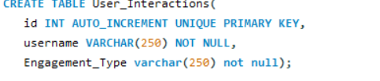
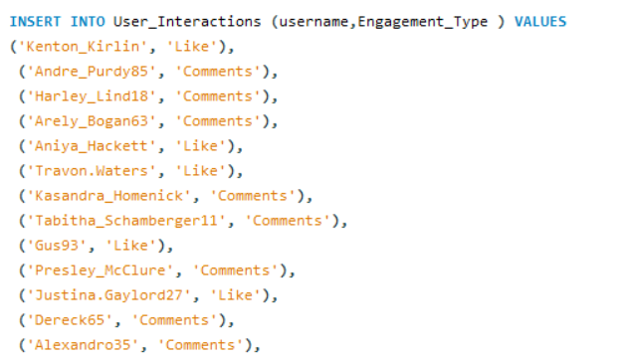
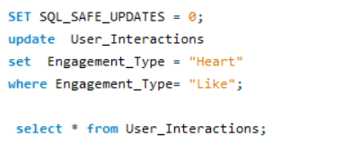
Output:
